Application Number | 07/2020/01087/FUL
Address | 220A Cocker Road  Walton Summit Industrial Estate  Bamber Bridge  Preston  Lancashire  PR5 8BP
Applicant | C/O Cassidy + Ashton

Agent
Mr Simon Newall
7 East Cliff
Preston
PR1 3JE
United Kingdom

Development | Erection of a side extension including internal mezzanine floor
Officer Recommendation  Officer Name | Approval with Conditions  Mr Chris Sowerby

Date application valid | 22.12.2020
Target Determination Date | 06.05.2021
Extension of Time | 06.04.2021

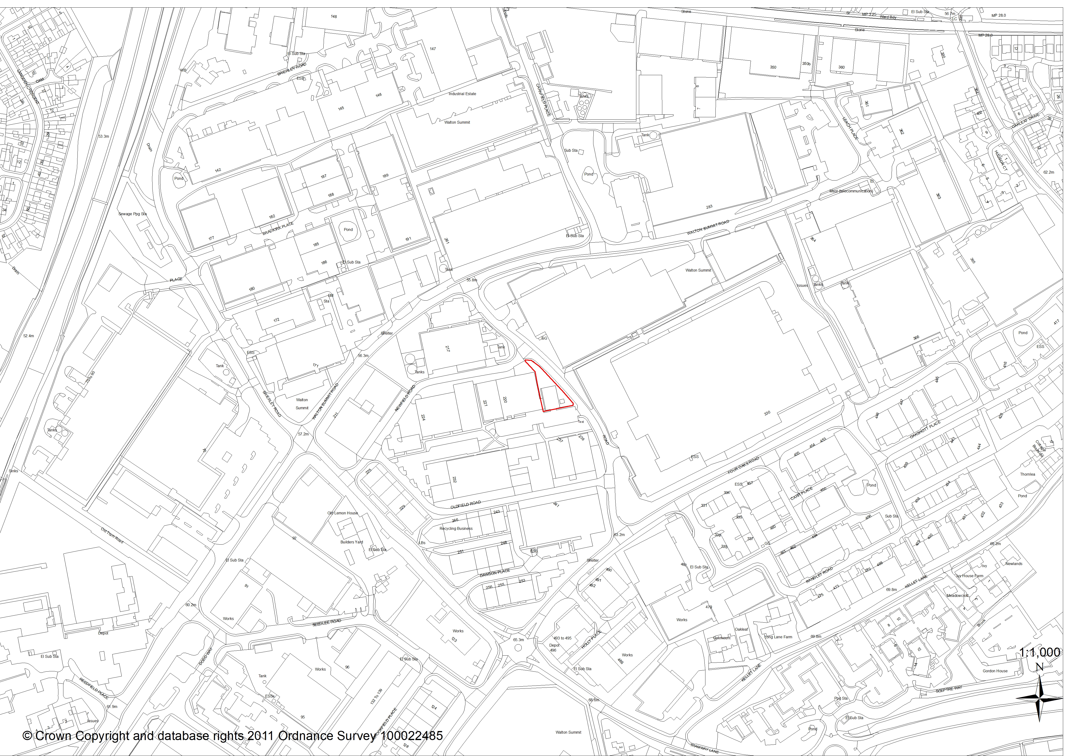

1. REPORT SUMMARY
1.1 The application relates to a 0.1 hectare parcel of land to west of Cocker Road within the Walton Summit Industrial Estate. The site comprises of an area of hardstanding used for car parking and a grassed area. The application site and the surrounding area are allocated as an Employment Area under Policy E2 of the South Ribble Local Plan.

1.2 The proposal is for the erection of an extension to the side of the unit which is proposed to include a mezzanine floor. The extension would comprise of additional storage and office space.

1.3 The proposed extension measures 20m (width) x 42.5m (depth) x 5-7.1m (height) with a pitched roof. A roller shutter door is proposed on the front elevation together with ground and first floor windows.

1.4 The proposed extension and alterations are sympathetic to the design of the existing building and will not have a detrimental impact on the character and appearance of the area. There are no nearby residential properties that the development will impact upon.

1.5 The proposed development would result in the loss of approximately 10 car parking spaces, 68 car parking spaces would however remain. County Highways have acknowledged whilst the proposal will result in a reduction of available parking the site “will still provide a level of parking that is acceptable for the overall size of the development”.

1.6 The proposal accords with Policies 1 and 17 of the Core Strategy together with Policies E2, F1, G13 and G17 of the South Ribble Local Plan. The application is therefore recommended for approval subject to the imposition of conditions.

2. APPLICATION SITE AND SURROUNDING AREA

2.1 The application relates to a 0.1 hectare parcel of land to west of Cocker Road within the Walton Summit Industrial Estate. The site comprises of an area of hardstanding used for car parking and a grassed area.

2.2 To the west of the application site is the associated warehouse unit which is currently occupied by Lookers Parts Centre. A further area of car parking is present to the south of the building.

2.3 The surrounding area is wholly a mixture of industrial, light industrial and storage and distribution uses.

2.4 The application site and the surrounding area are allocated as an Employment Area under Policy E2 of the South Ribble Local Plan.

3. SITE HISTORY
3.1 In 1996 planning permission (07/1996/0521) was granted for an extension to the building and the creation of a despatch depot.

In 1992 planning permission (07/1992/0460) was granted for external alterations to the building and the creation of a mezzanine floor.

In 1989 planning permission (07/1989/0374) was granted for an extension to an industrial unit and extension of a car park area.

In 1986 planning permission (07/1986/0210) was granted for an extension to the industrial unit.

In 1984 advertisement consent (07/1984/0623) was granted for an illuminated projection sign.

4. PROPOSAL
4.1 Planning permission is sought for the erection of an extension to the side of the unit which is proposed to include a mezzanine floor. The extension would comprise of additional storage and office space.

4.2 The proposed extension measures 20m (width) x 42.5m (depth) x 5-7.1m (height) with a pitched roof. A roller shutter door is proposed on the front elevation together with ground and first floor windows.

4.3 All materials are to match that of the existing building, where appropriate, with Green vertical composite panels on a brick base.

5. REPRESENTATIONS
5.1 No letter of representation have been received in relation to the proposal.

6. CONSULTATION REPLIES

County Highways have raised no objections to the proposal confirming they are of the opinion that the proposal “would not have a severe impact on highway safety or capacity within the immediate vicinity of the site”. Whilst it is acknowledged that the proposal will result in a reduction of available parking County Highways have confirmed “the site will still provide a level of parking that is acceptable for the overall size of the development”.

The imposition of a condition relating to the agreement of a Construction Management Plan has been recommended.

Environmental Health have raised no objections to the proposal.

The Local Authority’s Arboricultural Officer has raised no objections to the proposal.

The Local Lead Flood Authority (LCC) have raised no objections to the proposal.

7. MATERIAL CONSIDERATIONS

Policy Considerations

7.1 i) NPPF
7.1.1 The NPPF promotes a presumption in favour of sustainable development and supports sustainable economic development, stating “Planning policies and decisions should help create the conditions in which businesses can invest, expand and adapt. Significant weight should be placed on the need to support economic growth and productivity, taking into account both local business need and wider opportunities for development.” (para. 80)

7.2 ii) Core Strategy Policy Considerations
7.2.1 Policy 1 of the Core Strategy is entitled ‘Locating Growth’ and encourages the focussing of growth and investment in the Key Service Centres of Chorley and Leyland and the other main urban areas in South Ribble.

7.2.2Policy 10 of the Core Strategy is entitled ‘Employment Premises and Sites’ and highlights the need to protect sites last used and allocated for employment for future employments use.

7.3 iii) South Ribble Local Plan
7.3.1 The site is within an area of land designated as E2: Protection of Employment Areas and Sites in the South Ribble Local Plan.

7.3.2 Policy E2 protects land “for employment uses including business, general industrial or storage and distribution”. As the proposed extension relates to an existing storage and distribution use the proposal accords with the requirements of Policy E2.

7.4 Character / Appearance
7.4.1 Policy G17 of the Local Plan, amongst other things, requires development to be well related to neighbouring buildings and the locality in terms of its size, scale and intensity (plot coverage) and Policy 17 of the Core Strategy expects new buildings to “take account of the character and appearance of the local area”.

7.4.2 A mixture of buildings scales are present within the Walton Park Industrial Estate. With this variety present the scale and siting of the proposed extension will not be unduly prominent.

7.4.3 The extension proposed to be finished with Green vertical composite panels on a brick base to match the existing building. The proposed development would be in keeping with the character of the local area and complies with Core Strategy Policy 17 and Policy G17 of the South Ribble Local Plan.

7.5 Relationship To Neighbours
7.5.1 There are no nearby residential properties.

7.6 Highway Issues
7.6.1 The proposed development would result in the loss of approximately 10 car parking spaces, 68 car parking spaces would however remain. County Highways have acknowledged whilst the proposal will result in a reduction of available parking the site “will still provide a level of parking that is acceptable for the overall size of the development”.

7.6.2 No objections have been received from County Highways who are of the opinion that the proposal “would not have a severe impact on highway safety or capacity within the immediate vicinity of the site”.

8. CONCLUSION
8.1 The proposed erection of an extension to the side of the unit accords with the requirements of Policy E2 and is considered to be acceptable. The proposed development is not considered to be out of character with the area and there are no nearby residential properties that would be unduly affected. County Highways have raised no objections to the proposal, advising the off-street car parking provision that would remain is acceptable. Whilst 8 trees require removal mitigation planting can be secured through the imposition of a suitably worded condition.

The proposed development is deemed to be in accord with Policies 1 and 17 of the Core Strategy together with Policies E2, F1, G13 and G17 of the South Ribble Local Plan. The application is therefore recommended for approval subject to the imposition of conditions.

RECOMMENDED CONDITIONS:

1. That the development must be begun not later than the expiration of three years beginning with the date of this permission.

REASON: Required to be imposed pursuant to section 91 of the Town and Country Planning Act 1990.

2. The development, hereby permitted, shall be carried out in accordance with the submitted approved plans IMG-CAA-V1-XX-DR-A-1000 P3 (Site Location Plan), IMG-CAA-V1-XX-DR-A-2000 P1 (GA Plans), 10617 2000 P2 (Proposed GA Plans and Roof Plans) and IMA-CAA-V1-XX-DR-A-1002 P1 (Proposed Site Layout).

REASON: To ensure a satisfactory standard of development in accordance with Policy 17 in the Central Lancashire Core Strategy and Policy G17 of the South Ribble Local Plan.

4. No development shall take place, including any further works of demolition, until a Construction Method Statement has been submitted to, and approved in writing by, the local planning authority. The approved Statement shall be adhered to throughout the construction period. The Statement shall provide for:

(i) measures to control the emission of dust and dirt during construction
(ii) measures to control the emission of noise during construction
(iii) a scheme for recycling/disposing of waste resulting from demolition and construction works
(iv) the parking of vehicles of site operatives and visitors
(v) loading and unloading of plant and materials
(vi) storage of plant and materials used in constructing the development
(vii) the location of the site compound
(viii) suitable wheel washing/road sweeping measures
(ix) details of all external lighting to be used during construction
(x) Periods when plant and materials trips should not be made to and from the site (mainly peak hours but the developer to identify times when trips of this nature should not be made)
(xi) Measures to ensure that construction and delivery vehicles do not impede access to adjoining units and obstruct the public highway

REASON: To safeguard the amenities of neighbouring properties and to protect existing road users in accordance with Policy 17 of the Central Lancashire Core Strategy.

RECOMMENDATION:

Approval with Conditions.

RECOMMENDED CONDITIONS:

RELEVANT POLICY

17 Design of New Buildings (Core Strategy Policy)

POLE2 Protection of Employment Areas and Sites

POLF1 Car Parking

POLG13 Trees, Woodlands and Development

POLG17 Design Criteria for New Development

Note:

